6675 Z1
ATTACHMENT A-2
Laboratory Sample Transmittal Form

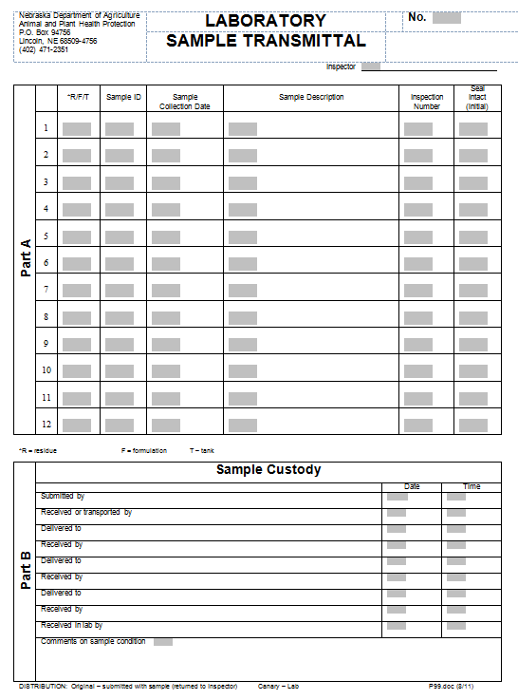

6675 Z1
ATTACHMENT A-3
NDA Sample Seal

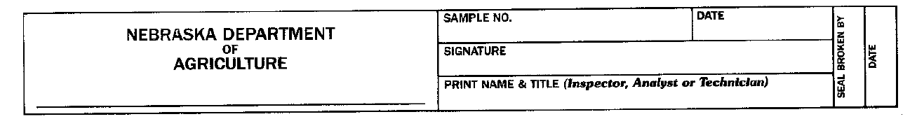

6675 Z1
ATTACHMENT A-4
NDA Sample Collection Report Form

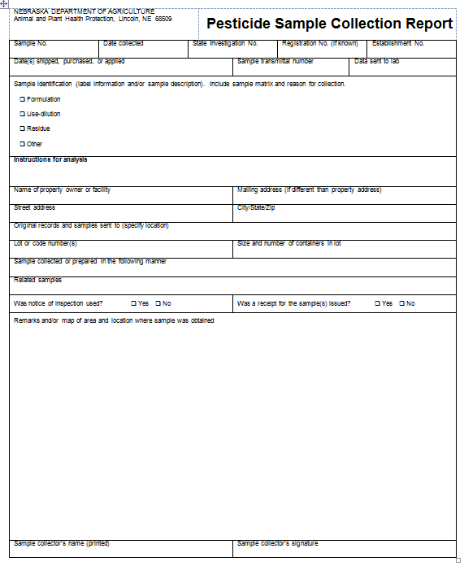

6675 Z1
ATTACHMENT A-5
NDA Notice of Inspection Form

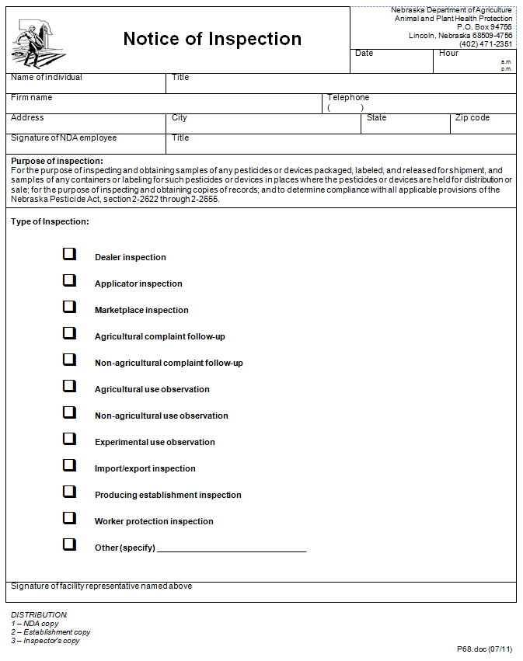

6675 Z1
ATTACHMENT A-6
NDA Receipt for Samples Form

